**Assignment No: 5**

**Text Identification Using OpenCV, Tesseract (OCR), and Deep Neural Network**

**Problem Statement:**

To implement a system that identifies and extracts text from images using OpenCV for image processing, Tesseract for Optical Character Recognition (OCR), and a deep neural network for further enhancement of text extraction.

**Objectives:**

1. **To implement a system for identifying and extracting text from images using a combination of image processing techniques, Optical Character Recognition (OCR), and deep learning for improved accuracy.**
2. **To leverage OpenCV for preprocessing images, Tesseract OCR for text extraction, and deep neural networks (DNNs) for enhanced recognition, especially in noisy or distorted images.**
3. **To explore real-world applications such as document digitization, license plate recognition, and automated data entry.**

**Theory:**

**Text identification in images involves extracting and recognizing textual information from various formats such as printed documents, scanned files, and natural scene images. The process consists of several stages: detecting the text regions, preprocessing the image for clarity, recognizing the characters, and converting the text into a machine-readable format.**

* **OpenCV: OpenCV is used for image processing tasks such as noise reduction, thresholding, and contour detection, which are essential for improving the quality of text regions in an image.**
* **Tesseract OCR: Tesseract is an open-source Optical Character Recognition engine that converts images containing text into machine-readable text. It can handle multiple languages and is often combined with image preprocessing for better accuracy.**
* **Deep Neural Networks (DNNs): DNNs can be used for enhancing OCR by learning complex patterns in images that might be difficult for traditional OCR engines to handle, such as handwritten text, blurred images, or distorted fonts.**

**Methodology:**

1. **Image Acquisition:**
   * **Load the image or capture it using a camera (for real-time applications).**
2. **Preprocessing with OpenCV:**
   * **Grayscale Conversion: Convert the image to grayscale to reduce the complexity of the image.**
   * **Noise Reduction: Apply Gaussian blur or median filtering to remove unwanted noise.**
   * **Thresholding: Use binary or adaptive thresholding to enhance the text and make it easier for the OCR engine to detect characters.**
   * **Edge Detection and Contour Detection: Use edge detection (e.g., Canny edge detector) to identify text regions within the image.**
3. **Text Extraction using Tesseract:**
   * **Pass the preprocessed image to the Tesseract OCR engine.**
   * **Tesseract identifies the text regions, recognizes the characters, and outputs the extracted text.**
4. **Text Enhancement using Deep Neural Networks:**
   * **For complex images (e.g., handwritten or distorted text), apply a DNN to classify or enhance text regions.**
   * **DNNs can be trained to identify problematic text regions and enhance recognition accuracy by refining the image before OCR.**
5. **Post-processing:**
   * **Apply further processing like spell checking or language-specific adjustments to clean up and format the extracted text.**

**Working Principle / Algorithm:**

1. **Image Preprocessing:**
   * **Load the image and preprocess it using OpenCV techniques to remove noise, enhance contrast, and isolate text regions.**
2. **Text Region Detection:**
   * **Detect regions containing text using contour detection or other region-based approaches.**
3. **OCR with Tesseract:**
   * **Apply Tesseract to the detected text regions to extract characters.**
   * **OCR converts image-based text into a machine-readable string format.**
4. **DNN for Enhanced Recognition:**
   * **Feed the preprocessed image or text regions into a deep neural network to handle cases where OCR alone may not be sufficient (e.g., skewed or blurred text).**
5. **Output:**
   * **The final extracted and processed text is displayed or saved for further use.**

**Advantages:**

1. **High Accuracy: Combining OpenCV, Tesseract, and DNNs enhances text detection and extraction, especially in challenging scenarios like poor lighting, blurred images, or unusual fonts.**
2. **Versatility: The system can handle a variety of text inputs, including printed text, handwritten text, and text from natural scenes.**
3. **Automated Workflow: This solution automates the extraction of text from images, reducing the need for manual data entry.**
4. **Real-Time Capability: By utilizing OpenCV’s image processing features, the system can be adapted for real-time text recognition applications such as license plate reading or document scanning.**

**Disadvantages / Limitations:**

1. **Processing Time: Complex preprocessing and neural network-based enhancement can be computationally expensive, leading to slower real-time performance.**
2. **Dependency on Image Quality: OCR and text recognition accuracy heavily depend on the quality of the input image. Poor-quality images with noise, low resolution, or poor lighting can reduce accuracy.**
3. **Training Requirement for DNNs: Training a deep neural network to handle specific cases (e.g., distorted or handwritten text) requires large labeled datasets and considerable computational resources.**
4. **Limited OCR Accuracy in Certain Cases: Even with preprocessing and DNN enhancement, some types of text (e.g., heavily distorted or extremely stylized fonts) may still present challenges for accurate recognition.**

**Diagram:**

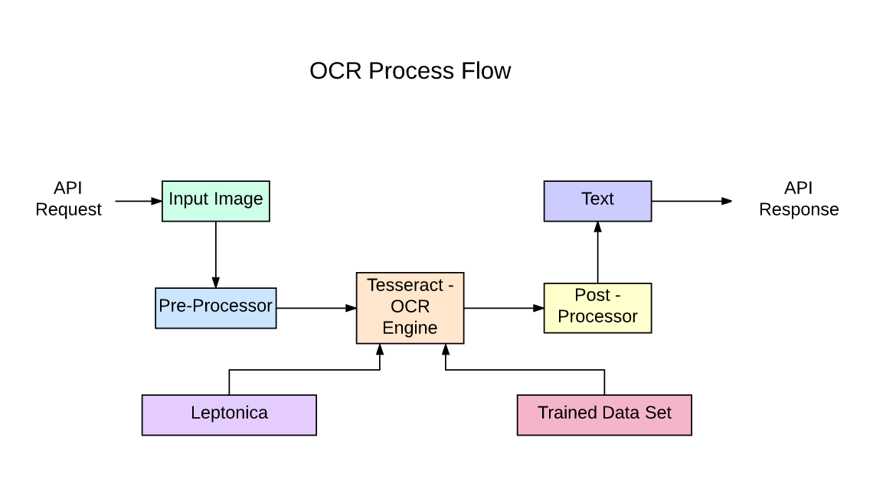

**Conclusion:**

The integration of OpenCV, Tesseract, and deep learning techniques provides a robust and versatile solution for text identification in images. This comprehensive approach facilitates accurate text extraction from a wide variety of formats and conditions, demonstrating its practical applicability in real-world scenarios such as document scanning, form processing, and data extraction from images.

While the system can achieve high accuracy under optimal conditions, performance can vary based on image quality, text clarity, and preprocessing effectiveness. Therefore, careful implementation and tuning of preprocessing techniques are crucial to maximize OCR performance.

Moreover, leveraging deep learning methods can significantly enhance the system's capabilities, especially in recognizing more complex text features and overcoming challenges posed by diverse fonts and layouts. Overall, this project highlights the importance of combining traditional image processing methods with advanced machine learning techniques to achieve superior results in text identification tasks.